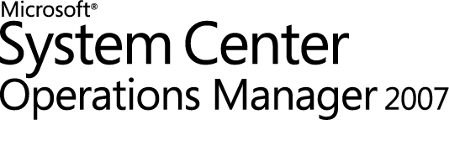

Microsoft Forefront Threat Management Gateway Management Pack Guide for Operations Manager 2007
Microsoft Corporation
Published: December, 2009
Send suggestions and comments about this document to mpgfeed@microsoft.com. Please include the management pack guide name with your feedback.
Copyright
Information in this document, including URL and other Internet Web site references, is subject to change without notice. Unless otherwise noted, the companies, organizations, products, domain names, e-mail addresses, logos, people, places, and events depicted in examples herein are fictitious. No association with any real company, organization, product, domain name, e-mail address, logo, person, place, or event is intended or should be inferred. Complying with all applicable copyright laws is the responsibility of the user. Without limiting the rights under copyright, no part of this document may be reproduced, stored in or introduced into a retrieval system, or transmitted in any form or by any means (electronic, mechanical, photocopying, recording, or otherwise), or for any purpose, without the express written permission of Microsoft Corporation.
Microsoft may have patents, patent applications, trademarks, copyrights, or other intellectual property rights covering subject matter in this document. Except as expressly provided in any written license agreement from Microsoft, the furnishing of this document does not give you any license to these patents, trademarks, copyrights, or other intellectual property.
© 2009 Microsoft Corporation. All rights reserved.
Microsoft, MS-DOS, Windows, Windows Server, and Active Directory are either registered trademarks or trademarks of Microsoft Corporation in the United States and/or other countries.
All other trademarks are property of their respective owners.

Contents
Microsoft Forefront TMG Management Pack Guide 5
Introduction to the Forefront TMG Management Pack 5
What's New 6
Supported Configurations 6
Requirements 7
Getting Started 8
Before You Import the Management Pack 8
Configure the Operations Manager Server to Allow Manual Agent Deployment on Forefront TMG Computers 8
Create a New Access Rule for Operations Manager 9
Install the Operations Manager Agent on the Forefront TMG Computers 10
Enable the TMG topology view 11
Files in This Management Pack 12
How to Import the Forefront TMG Management Pack 12
Create a New Management Pack for Customizations 12
Optional Configuration 13
Tuning Performance Threshold Rules 14
Security Considerations 14
Understanding Management Pack Operations 14
Objects the Management Pack Discovers 15
Classes 18
How Health Rolls Up 19
Key Monitoring Scenarios 20
Appendix: Reports 21
Appendix: Scripts 22

Microsoft Forefront TMG Management Pack Guide
Microsoft Forefront Threat Management Gateway (TMG) is an advanced stateful packet and application-layer inspection firewall, virtual private network (VPN), and Web cache solution, that helps securely publish content for remote access, connect and secure branch offices, and defend against external and internal Web-based threats. Forefront TMG enables you to easily maximize existing information technology (IT) investments by improving network security and performance.
Document Version
This guide was written based on the 7.0.7695.100 version of the Forefront TMG Management Pack.
Revision History

Release Date | Changes
December, 2009 | Original release of this guide

The Forefront TMG Management Pack guide provides the following information:
• Introduction to the Forefront TMG Management Pack
• Requirements
• Getting Started
• Optional Configuration
• Understanding Management Pack Operations
• Appendix: Reports
• Appendix: Scripts
Introduction to the Forefront TMG Management Pack
The Forefront Threat Management Gateway (TMG) Management Pack monitors Forefront TMG events and alerts, Forefront TMG components and Forefront TMG connectivity.
The Forefront TMG Management Pack includes monitors, rules, and views for monitoring and troubleshooting problems on Forefront TMG servers. This management pack also includes health models, based on the Service Modeling Language (SML), to analyze the performance, availability, configuration and security inputs, as well as the status of Forefront TMG, to determine the overall status of the system.
Getting the Latest Management Pack and Documentation
You can find the Forefront TMG Management Pack in the System Center Operations Manager 2007 Catalog (http://go.microsoft.com/fwlink/?LinkId=82105).
What's New
The following features are included in this release of the Forefront TMG Management Pack:
• Array Health Rolldown
• Discovery and monitoring for new Forefront TMG features such as:
• URL Filtering
• SMTP Protection
• EMP - Enterprise Malware Inspection
• SIP – Session Initiation Protocol
• ISP Redundancy
• NIS - Network Inspection System
• Full Topology discovery
• More than 70 new events
• More than 10 new performance counters
Supported Configurations
Two editions of Forefront TMG are available: Standard and Enterprise.
The Forefront TMG Management Pack supports any combination of standalone Forefront TMG servers or arrays of Forefront TMG servers. This management pack automatically recognizes an array deployment of Forefront TMG servers, and groups all array members under that array. To ensure correct monitoring of the array members, install the SCOM monitoring agent on each TMG server.
If the monitoring agent is already installed, you do not need to reinstall it.
Note
The following table details the supported configurations for the Forefront TMG Management Pack.

Configuration | Support
Windows Server 2008 | Yes, 64-bit only
Array setup | Yes
Enterprise setup | Yes
Agentless monitoring | No

Requirements
In order for the Forefront TMG Management Pack to function properly, there are a number of additional requirements:
• Each Forefront TMG computer must be managed by System Center Operations Manager 2007.
• Operations Manager must be configured to allow manual agent installations (approvals can be manual or automatic). Push installs require remote procedure call (RPC) and Server Message Block (SMB), which are blocked by default on Forefront TMG computers.
• Operations Manager agents must be installed manually on the Forefront TMG computers (and approved in the Operations Console if not configured for automatic approval).
• To enable monitoring of Forefront TMG computers, one of the following requirements must be met:
• Forefront TMG computers must be in the same domain as the Operations Manager server, or in a domain with Kerberos trust to the Management Server’s domain.
• If the preceding requirement is not met, digital certificates must be installed on the Forefront TMG computers and Operations Manager servers, and configured using the MomCertImport.exe tool.
• An access rule must be configured in Forefront TMG to allow the Forefront TMG computer to communicate with the Management Servers. This will be from the Local Host network to the network, computer, or computer set representing the Management Servers on TCP port 5723. The access rule is per-array for Forefront TMG Enterprise Edition and per-server for Forefront TMG Standard Edition.
• The Forefront TMG Management component (a Microsoft Management Console) should be installed on the local computer of the Operations Manager operator, or the task to start the console will fail.
• If the Forefront TMG Management console is installed on the operator’s computer, the operator should be added to one of the following Forefront TMG roles:
• Forefront TMG Administrator (Array or Enterprise Administrator in Enterprise Edition)—Allows full access to Forefront TMG monitoring and configuration.
• Forefront TMG Auditor (Array or Enterprise Auditor in Enterprise Edition)—Allows full access to Forefront TMG monitoring, able to view Forefront TMG configuration, and able to configure logging and alerting.
• Forefront TMG Monitoring Auditor (Array or Enterprise Monitoring Auditor in Enterprise Edition)—Allows full access to Forefront TMG monitoring only.
• If the Forefront TMG Management console is installed on the operator’s computer, the operator’s computer should be added to one of the following Forefront TMG computer sets: Remote Management Computers or Enterprise Remote Management Computers. This permits the console on the computer to connect to the Forefront TMG RPC interface.
• AdamSites.exe (http://go.microsoft.com/fwlink/?LinkId=168771) should be installed in the %ProgramFiles%\Microsoft Forefront TMG folder of the Forefront TMG computer hosting the configuration storage server (CSS) role (refer to Objects the Management Pack Discovers for more information) for the respective tasks to function.
• Dnstools.exe (http://go.microsoft.com/fwlink/?LinkId=168772) should be installed in the %ProgramFiles%\Microsoft Forefront TMG folder of the Forefront TMG computer hosting the Firewall role (refer to Objects the Management Pack Discovers for more information) for the respective tasks to function.
Getting Started
The following topics describe the actions you should take before you import the management pack, any steps you should take after you import the management pack, and information about customizations:
• Before You Import the Management Pack
• How to Import the Forefront TMG Management Pack
• Create a New Management Pack for Customizations
Before You Import the Management Pack
Before you import the Forefront TMG Management Pack, note the following limitations:
• You must remove previous versions of the Forefront TMG Management Pack before you can import the latest version.
• For Forefront TMG environments that have both DNS and DHCP connectivity verifiers enabled, if one connectivity verifier fails, the alert will identify the incorrect connectivity verifier as failing. This is a known issue and will be addressed in a future release of this management pack.
Before you import the Forefront TMG Management Pack, you must do the following:
• Configure the Operations Manager Server to Allow Manual Agent Deployment on Forefront TMG Computers.
• Create a New Access Rule for Operations Manager.
• Install the Operations Manager Agent on the Forefront TMG Computers.
• Enable the TMG topology view.
Configure the Operations Manager Server to Allow Manual Agent Deployment on Forefront TMG Computers
To configure management server settings for manual agent deployment on the Operations Manager 2007 server
1. In the Operations console, click Administration.
2. In the Administration pane, click Settings.
3. In the Settings pane, expand Type: Server, right-click Security, and then click Properties.
4. In the Global Management Server Settings - Security dialog box, in the General tab, click Review new manual agent installations in pending management view, and then click OK.
5. After completing the manual agent installation process and configuring the appropriate firewall rules on the Forefront TMG computer (described later), you must approve the agent for installation in the Pending Actions view in the Administration pane.

Create a New Access Rule for Operations Manager
The following procedure describes how to create a new access rule for remote monitoring of Forefront TMG computers using the Operations Manager agent. In Forefront TMG Enterprise Edition, this procedure must be performed for each array in which you want to deploy the Operations Manager agent. In Forefront TMG Standard Edition, this procedure must be performed on each Forefront TMG computer on which you want to deploy the Operations Manager agent.
To create a new access rule for the Operations Manager agent in Forefront TMG
1. Click Start, point to Programs, point to Microsoft Forefront TMG, and then click Forefront TMG Management.
2. Expand the Firewall Policy node under the required computer in the navigation pane.
3. Create a new computer set:
a. Click the Toolbox tab and select the Network Objects folder.
b. Click the New button and select Computer Set from the list.
c. Enter a name for the computer set (for example, SCOM set).
d. Add the Operation Manager server(s) to the computer set, and click OK when finished.
4. Click the Tasks tab and select Create Access Rule.
5. Name the access rule (for example, Operations Manager Agent), and then click Next.
6. On the Rule Action page, select Allow and then click Next.
7. On the This rule applies to page:
a. Choose Selected Protocols from the list and then click the Add button
b. In the Add Protocols dialog box, expand the Infrastructure folder.
c. Select System Center Operation Manager Agent and click Add.
d. Select System Center Operation Manager Agent Installation, click Add and then click Close.
e. Click Next
8. On the Access Rule Sources page:
a. Click Add.
b. In the Add Network Entities dialog box, expand the Networks folder, select Local Host, click Add, and then click Close.
c. Click Next.
9. On the Access Rule Destinations page:
a. Click Add.
b. In the Add Network Entities dialog box, expand the Computer Sets folder, select the computer set (for example, SCOM set), click Add, and then click Close.
c. Click Next.
10. On the User Sets page, click Next.
11. On the Completing the New Access Rule Wizard page, click Finish.
12. Click Apply to save the changes and update the configuration.

Install the Operations Manager Agent on the Forefront TMG Computers
The Operations Manager agent runs on each computer that Operations Manager monitors. The Operations Manager agent is typically installed by starting the Discovery Wizard from the Operations Manager 2007 Administrator Console on the Operations Manager server. Because the Microsoft Firewall service blocks the traffic between the Operations Manager server and the Forefront TMG computers that are needed to install an Operations Manager agent, it is recommended that you install the Operations Manager agent manually on each Forefront TMG computer that you want to configure as an Operations Manager agent computer, as described in the following procedures.
To install the Operations Manager agent manually on an Forefront TMG computer
1. On the computer on which you want to install the agent, run SetupOM.exe from the Operations Manager 2007 installation media.
2. Click Agent to install an agent.
3. In the Agent Setup Wizard, select the Specify Management Group Information option.
4. On the Management Group Configuration page, specify the following:
• In the Management Group Name box, type the name of the management group to which the agent will connect.
• In the Management Server Name box, type the fully qualified domain name (FQDN) of the Operations Manager 2007 server.
5. Select either Local System or specify a domain user account for the agent action account.
6. Complete the Agent Setup Wizard.
To approve the agent on the Operations Manager server
1. In the Operations Manager Console, click the Administration button.
2. Click Administration, expand Administration, expand Device Management, and then click Pending Management.
3. In the Pending Management pane, select computers in Type: Manual Agent Install.
4. Right-click the computers, and then click Approve.
5. In the Manual Agent Install dialog box, click Approve to display the computers in the Agent Managed node showing that they are ready to be managed.
Note
Rejected agents remain in Pending Management until the agent is uninstalled for the Management Group.

Enable the TMG topology view
To enable the TMG topology view, you must configure all Forefront TMG servers to discover objects on other Forefront TMG servers, as follows:
1. Open the System Center Operations Manager Console, click the Administration tab, and then select Agent Managed.
2. For every computer in an array deployment that is monitored by this management pack:
a. Right-click the computer name and select Properties.
b. In the Agent Properties dialog box, click the Security tab.
c. On the Security tab, select Allow this agent to act as a proxy and discover managed objects on other computers, and then click OK.
You must restart the OpsMgr Health Service before the new agent proxy setting takes effect.
Important
If the number of agents in the environment makes it impractical to manually enable every Forefront TMG server, use the following PowerShell script:
param ($serverName,$groupDisplayName)
add-pssnapin "Microsoft.EnterpriseManagement.OperationsManager.Client";
set-location "OperationsManagerMonitoring::";
new-managementGroupConnection -ConnectionString:$serverName;
set-location $serverName;
$group = get-monitoringobject | where {$_.DisplayName -eq $groupDisplayName}
$relatedMonitoringObjects = $group.GetRelatedMonitoringObjects()
foreach($monitoringObject in $relatedMonitoringObjects)
{
$agent = get-agent | where {$_.PrincipalName -eq $monitoringObject.DisplayName}
if($agent -ne $null)
{
"Enabling proxying for " + $agent.PrincipalName
$agent.ProxyingEnabled = $true
$agent.ApplyChanges()
}
}
To run the script, copy and paste the above script to Notepad, save the file on the management server as C:\EnableProxying.ps1 and run it using the following syntax:
powershell C:\EnableProxying.ps1 -ServerName:localhost -groupDisplayName:'Microsoft Forefront TMG Computers'
The above command will enable agent proxy on the local management server for all agents that are members of the computer group with display name 'Microsoft Forefront TMG Computers'. To run this script against a different computer group, change the computer group display name in the -groupDisplayName parameter.
Files in This Management Pack
The Forefront TMG Management Pack includes the following files:
• Microsoft.Forefront.TMG.mp
• OM2007_MP_TMG.doc
• EULA.rtf
An extra file is included in a localized Forefront TMG Management Pack called:
Microsoft.Forefront.TMG.[LNG].mp (Where [LNG] is replaced by 3 letters indicating the language of the pack).
Notes
Both the .mp files must be imported in Operations Manager 2007 to enable the language support.
How to Import the Forefront TMG Management Pack
For instructions about importing a management pack, see How to Import a Management Pack in Operations Manager 2007 (http://go.microsoft.com/fwlink/?LinkId=142351).
After the Forefront TMG Management Pack is imported, create a new management pack in which you store overrides and other customizations.
After importing the Forefront TMG Management Pack, expect at least 4 hours before the management pack finishes discovering objects and starts monitoring them.
Note

Create a New Management Pack for Customizations
Most vendor management packs are sealed so that you cannot change any of the original settings in the management pack file. However, you can create customizations, such as overrides or new monitoring objects, and save them to a different management pack. By default, Operations Manager 2007 saves all customizations to the Default Management Pack. As a best practice, you should create a separate management pack for each sealed management pack you want to customize.
Creating a new management pack for storing overrides has the following advantages:
• It simplifies the process of exporting customizations that were created in your test and pre-production environments to your production environment. For example, instead of exporting the Default Management Pack that contains customizations from multiple management packs, you can export just the management pack that contains customizations of a single management pack.
• You can delete the original management pack without the need to first delete the Default Management Pack. A management pack that contains customizations is dependent on the original management pack. This dependency requires you to delete the management pack with customizations before you can delete the original management pack. If all of your customizations are saved to the Default Management Pack, you must delete the Default Management Pack before you can delete an original management pack.
• It is easier to track and update customizations to individual management packs.
For more information about sealed and unsealed management packs, see Management Pack Formats (http://go.microsoft.com/fwlink/?LinkId=108355). For more information about management pack customizations and the Default Management Pack, see About Management Packs in Operations Manager 2007 (http://go.microsoft.com/fwlink/?LinkId=108356).
Optional Configuration
After you import the Forefront TMG Management Pack, it begins to discover and monitor computers without any additional configuration. You can, however, configure the Forefront TMG Management Pack for your environment and preferences. For example, you can enable rules which are disabled by default; or if performance measuring rules, which are enabled by default, degrade performance on your servers with slow WAN links, you can turn them off.
To enable a rule
1. In the Operations Console, on the Navigation menu, click Authoring.
2. In the navigation pane, expand Management Pack Objects, and then click Rules.
Note
To show rules for the Forefront TMG Management Pack only, on the toolbar, click Scope, and then under Target, select the check boxes for the appropriate server components.
3. Under Rules, right-click the rule that you want to turn on, point to Overrides, point to Override the Rule, and then click For all objects of type: <type of object>.
4. Under Override-controlled parameters, in the Override column, select the Enabled option.
5. In the Override Setting column, in the drop-down menu, click True, and then click OK.
To disable a rule
1. In the Operations Console, on the Navigation menu, click Authoring.
2. In the navigation pane, expand Management Pack Objects, and then click Rules.
Note
To show rules for the Forefront TMG Management Pack only, on the toolbar, click Scope, and then under Target, select the check boxes for the appropriate server components.
3. Under Rules, right-click the rule that you want to turn off, point to Overrides, point to Disable the Rule, and then click For all objects of type: <type of object>.

Tuning Performance Threshold Rules
The following is an example of a performance threshold rule that has a default threshold that might require additional tuning to suit your environment. You should evaluate this rule to determine whether the default threshold is appropriate for your environment. If the default threshold is not appropriate for your environment, you should baseline the relevant performance counter, and then adjust the threshold by overriding it.

Rule Name | Default Threshold
Forefront TMG Server: Firewall - Available Worker Threads Monitor | 3 (the monitor is unhealthy if the performance counter value is zero for 3 consecutive samples)

Security Considerations
All the management pack tasks require that the Action Account have Admin user rights on the Forefront TMG agent computer. No tasks can be run using a low-privilege account.
Understanding Management Pack Operations
The following topics describe the Forefront TMG Management Pack operations, including:
• Objects the Management Pack Discovers
• Classes
• How Health Rolls Up
• Key Monitoring Scenarios
Objects the Management Pack Discovers
The Forefront TMG Management Pack automatically discovers the object types described in the following table.

Name | Description | Discovery
Microsoft Forefront TMG Configuration Storage Server role | This class represents an installation of a Forefront TMG configuration storage server on a server running the Windows Server operating system. | An object of this type is discovered on every server running Windows Server where Forefront TMG configuration data is stored.
Microsoft Forefront TMG Firewall role | This class represents an installation of a Forefront TMG Firewall server on a server running Windows Server. | An object of this type is discovered on every Windows server running Windows Server, where the base Forefront TMG firewall service is running.
Microsoft Forefront TMG Cache-Enabled Firewall Component | This class represents the Forefront TMG caching feature when it is enabled on an installation of a Forefront TMG Firewall. | Instances of the TMG Cache-Enabled class are discovered by the FPC COM object on Forefront TMG computers.
Microsoft Forefront TMG VPN-Enabled Firewall Component | This class represents the Forefront TMG virtual private network (VPN) feature when it is enabled on an installation of a Forefront TMG Firewall server. | Instances of the TMG VPN-Enabled class are discovered by the FPC COM object on Forefront TMG computers.
Microsoft Forefront TMG NLB-Enabled Firewall Component | This class represents the Forefront TMG Network Load Balancing (NLB) feature when it is enabled on an installation of an Forefront TMG Firewall server. | An object of this type is discovered on every server running Windows Server with a Forefront TMG Firewall base installation, where the NLB feature is enabled.
WebProxy-Enabled Firewall Component | This class represents the Forefront TMG Web Proxy feature when it is enabled on an installation of an Forefront TMG Firewall server. | An object of this type is discovered on every server running Windows Server with a Forefront TMG Firewall base installation, where the Web Proxy feature is enabled.
Microsoft Forefront TMG Publishing-Enabled Firewall Component | This class represents the Forefront TMG Publishing feature when it is enabled on an installation of a Forefront TMG Firewall server. | An object of this type is discovered on every server running Windows Server with a Forefront TMG Firewall base installation, where publishing rules are applied to this server.
Microsoft Forefront TMG Logging: Text-File | This class represents logging to a text file on a Forefront TMG computer. | An object of this type is discovered on a server running Windows Server with a Forefront TMG installation, where the Text-File logging feature is in use.
Microsoft Forefront TMG Logging: SQL Server Express Database | This class represents logging to an SQL Server Express Database (local MSDE) on a Forefront TMG computer. | An object of this type is discovered on a server running Windows Server with a Forefront TMG installation, where the SQL Server Express Database logging feature is in use.
Microsoft Forefront TMG Logging: SQL Database | This class represents logging to an SQL Database on a Forefront TMG computer. | An object of this type is discovered on a server running Windows Server with a Forefront TMG installation, where the SQL Database logging feature is in use.
Microsoft Forefront TMG Enterprise | This class represents an object of type Enterprise as defined in the Forefront TMG architecture. | Instances of the TMG Enterprise class are discovered by the FPC COM object on Forefront TMG computers.
Microsoft Forefront TMG Array | This class represents an object of type Array as defined in the Forefront TMG architecture. An object of this type is a logical container for servers. | Instances of the TMG Array class are discovered by the FPC COM object on Forefront TMG computers.
Microsoft Forefront TMG Malware Inspection Firewall Component | This class represents the Forefront TMG Malware Inspection feature when it is enabled on an installation of a Forefront TMG Firewall server. | Instances of the TMG Malware Inspection class are discovered by the FPC COM object on Forefront TMG computers.
Microsoft Forefront TMG SMTP Protection Firewall Component | This class represents the Forefront TMG SMTP Protection feature when it is enabled on an installation of a Forefront TMG Firewall server. | Instances of the TMG SMTP Protection class are discovered by the FPC COM object on Forefront TMG computers.
Microsoft Forefront TMG SIP Firewall Component | This class represents the Forefront TMG SIP feature when it is enabled on an installation of a Forefront TMG Firewall server. | Instances of the TMG SIP class are discovered by the FPC COM object on Forefront TMG computers.
Microsoft Forefront TMG URL Filtering Firewall Component | This class represents the Forefront TMG URL Filtering feature when it is enabled on an installation of a Forefront TMG Firewall server. | Instances of the TMG URL Filtering class are discovered by the FPC COM object on Forefront TMG computers.
Microsoft Forefront TMG NIS Firewall Component | This class represents the Forefront TMG Network Inspection System (NIS) feature when it is enabled on an installation of a Forefront TMG Firewall server. | Instances of the TMG NIS class are discovered by the FPC COM object on Forefront TMG computers.
Microsoft Forefront TMG ISP Redundancy Firewall Component | This class represents the Forefront TMG ISP Redundancy feature when it is enabled on an installation of a Forefront TMG Firewall server. | Instances of the TMG ISP Redundancy class are discovered by the FPC COM object on Forefront TMG computers.
Microsoft Forefront TMG Enterprise Management Server | This class represents an object of type EMS as defined in the Forefront TMG architecture. | Instances of the TMG EMS class are discovered by the FPC COM object on Forefront TMG computers.

Classes
The following diagrams show the classes defined in this management pack. Shaded boxes indicate classes that are defined in other management packs; the management pack that defines a class is shown in parentheses.
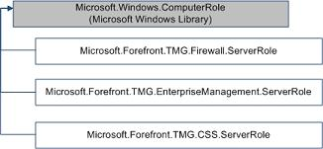

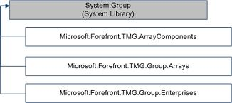

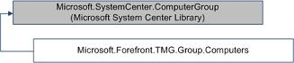

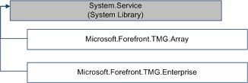

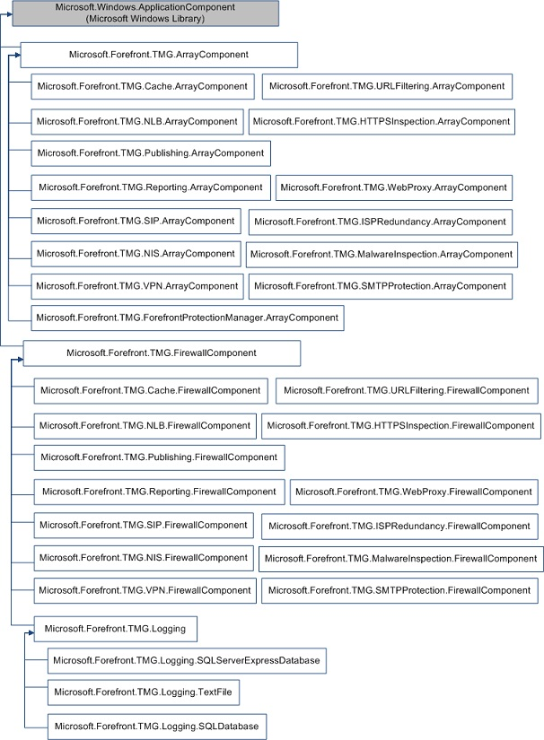

How Health Rolls Up
The following diagrams show how the health states of components roll up in this management pack, for Enterprise and Standalone Array modes.
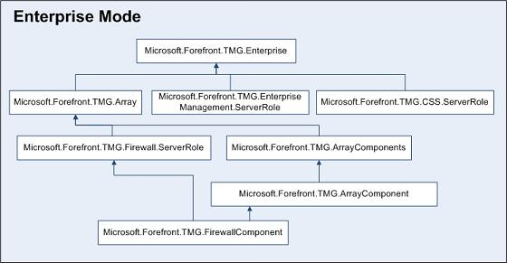

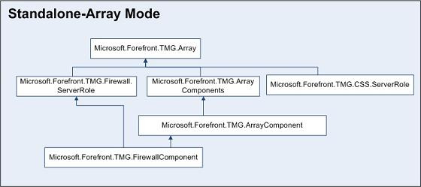

Key Monitoring Scenarios
The following table lists the key monitoring scenarios included in the Forefront TMG Management Pack:

Scenario | Description
Forefront TMG component monitoring | The following types of monitoring will be performed on Forefront TMG components:  • Event-based monitoring  • Script-based COM monitoring  • Performance threshold monitoring  • Service monitoring  • Performance collection
Forefront TMG connectivity monitoring | This scenario enables monitoring of the Forefront TMG computer’s connectivity to the services it is publishing, the Internet, and to infrastructure services (such as authentication and name resolution).

Appendix: Reports
The following reports are included in the Forefront TMG management pack.
You should allow up to thirty minutes for reports from a new management pack to appear in the Reporting console.
Note

Report Name | Type | Description
TMG Enterprise Configuration | Configuration | This report shows TMG enterprises and their properties.
TMG Array Configuration | Configuration | This report shows TMG arrays and their properties.
TMG CSS Configuration | Configuration | This report shows TMG configuration storage servers and their properties.
TMG Firewall Configuration | Configuration | This report shows TMG Firewall servers and their properties.
TMG Firewall Servers – TMG Performance | Performance | This report shows TMG-related performance data for TMG Firewall servers.
TMG Firewall Servers - Core Performance | Performance | This report shows server-related performance data for TMG Firewall servers.
Most Common Alerts |  | This report shows the most common alerts for TMG management packs.
Most Common Events |  | This report shows the most common events for TMG management packs.

Appendix: Scripts
The following scripts are included in the Forefront TMG management pack.

Script | Description
ReportingConfigurationStateMonitor.vbs | Outputs the monitor state for the "Reporting – Configuration State" monitor.
ReportingAvailabilityStateMonitor.vbs | Outputs the monitor state for the "Reporting – Availability State" monitor.
FirewallServerRoleTargetedDisc.vbs | A discovery script to indentify Firewall and array properties, runs on a firewall server.
FirewallHosts<ComponentName>RelDisc.vbs | A discovery script to indentify the specified component relationships on a firewall.
EMSTargetedTopologyDisc.vbs | A discovery script to indentify enterprise properties, runs on an EMS server.
<ComponentName>ComponentDiscovery.vbs | A discovery script to indentify the specified component on a firewall.
ArrayTargetedCSSDisc.vbs | A discovery script to indentify the CSS configuration in a standalone array.
Microsoft.Forefront.TMG.GeneralTasks.vbs | All the tasks available in the MP are run from this script.
ForefrontTMGLogDriveFreeSpaceMonitor.vbs | Outputs the monitor state for the "Logging - Log Drive Free Space" monitor.
ForefrontTMGAdMembershipMonitor.vbs | Outputs the monitor state for the "Firewall - Ad Membership" monitor.
ForefrontTMGConnVerMonitor.vbs | Outputs the monitor state for the "Firewall - Connectivity Verifiers" monitor.
ForefrontTMGConfigurationStateMonitor.vbs | Outputs the monitor state for the "Firewall – Configuration" monitor.
ForefrontTMGConnectivityStateMonitor.vbs | Outputs the monitor state for the "Firewall – Connectivity" monitor.

